Asilo, Rainier

2 ECE – A

Experiment 8: Pandas

Problem 1

A.

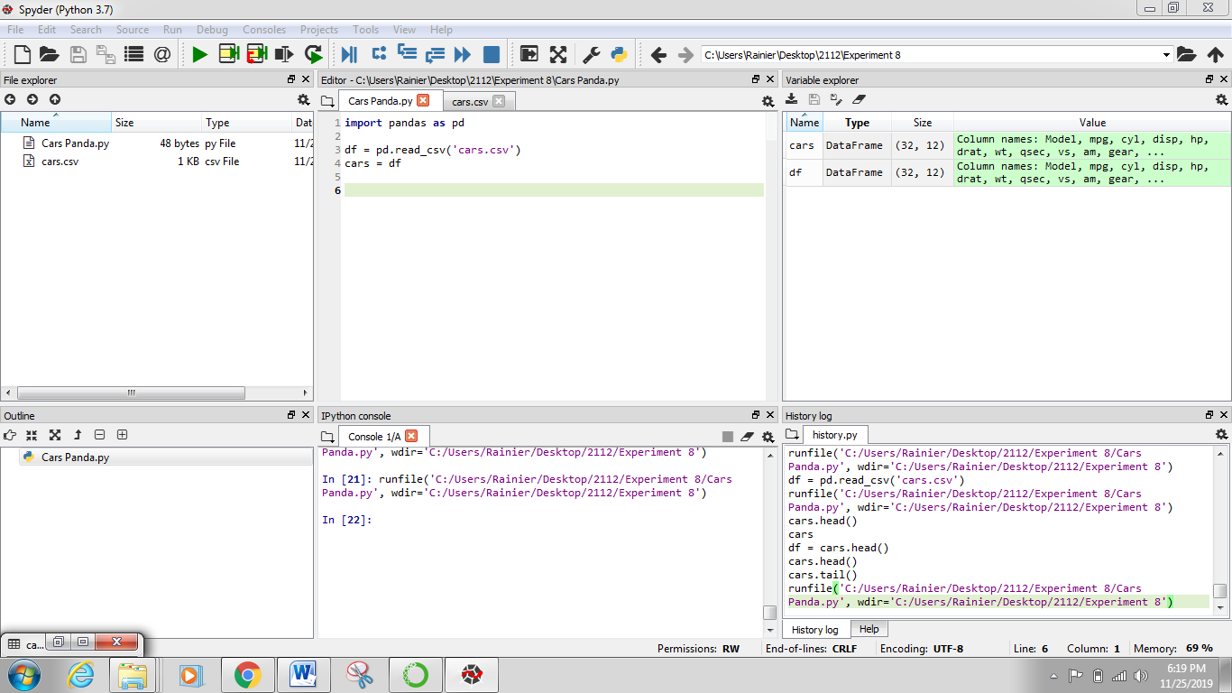



B.

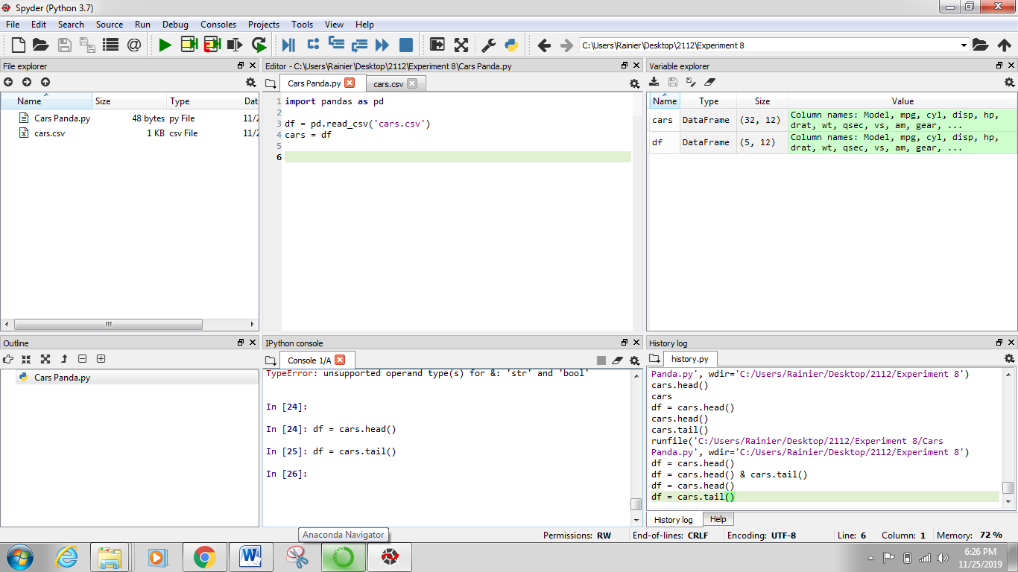

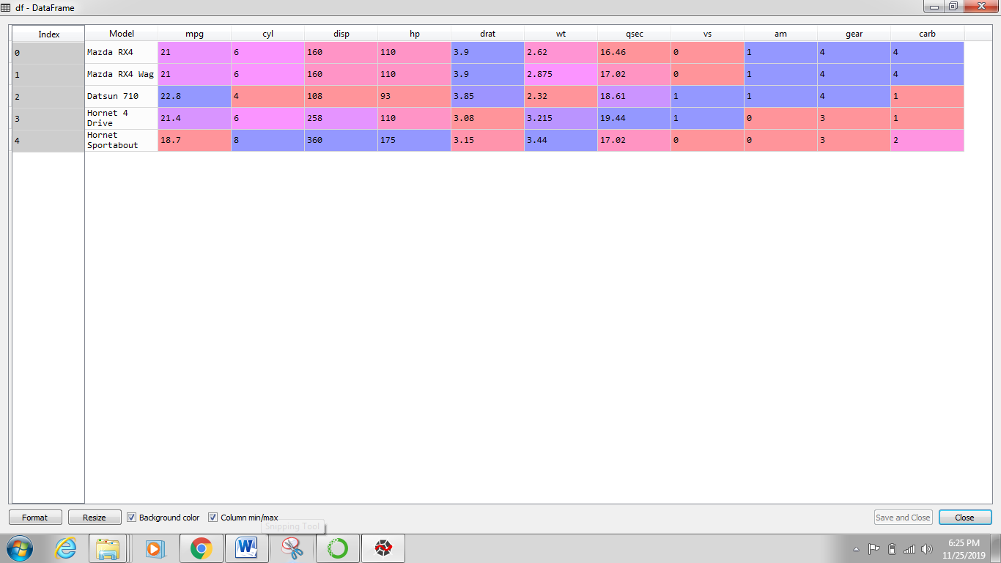

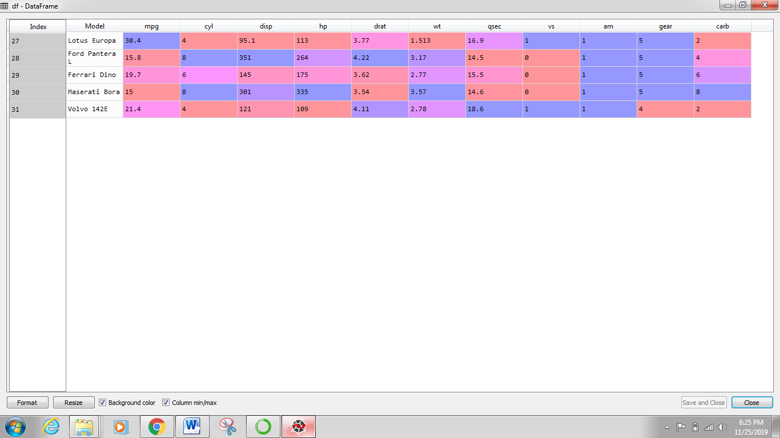

Problem 2

A.

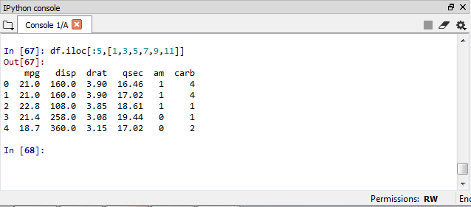

B.

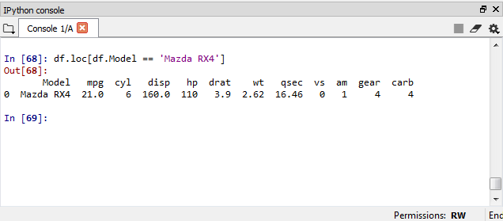

C.

Answer: cyl = 8

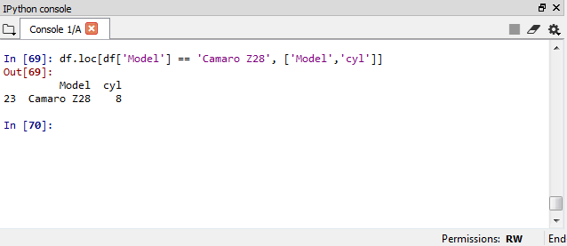

D.

Answer:

Mazda RX4; Cyl = 6; Gear = 4

Ford Pantera L; Cyl = 8; Gear = 5

Honda Civic; Cyl = 4; Gear = 4

